**Project Design Phase-II**

**Technology Stack (Architecture & Stack)**

|  |  |
| --- | --- |
| Date | 17 October 2022 |
| Team ID | PNT2022TMID23494 |
| Project Name | Fertilizers Recommendation System For Disease Prediction |
| Maximum Marks | 4 Marks |

**Technical Architecture:**

|  |  |  |  |
| --- | --- | --- | --- |
| **S.N**  **o** | **Component** | **Description** | **Technology** |
| 1. | User Interface | How the user interacts with the application .To depict the human-computer interaction and communication. | HTML, CSS,JSP |
| 2. | Application Logic-1 | A page to upload images as input | Python |

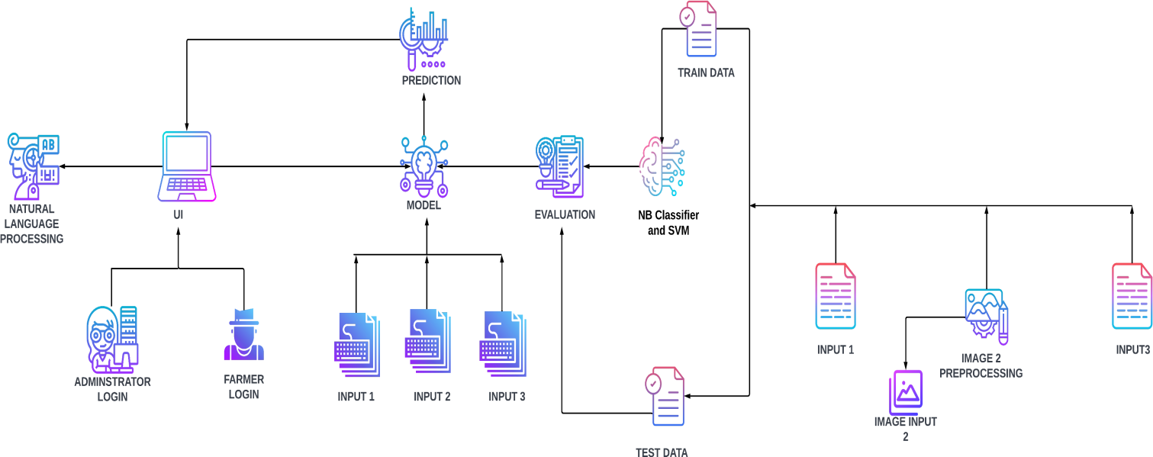

**Table-1 : Components & Technologies**

|  |  |  |  |
| --- | --- | --- | --- |
| 3. | Application Logic-2 | To use the Machine Learning model and predicting the result | Python |
| 4. | Database | Structured data-images | MySql |
| 5. | Cloud Database | Database that typically runs on a cloud computing platform and access to the database is provided as-a- service | IBM Cloud  Databases for  MySQL |
| 6. | File Storage | To store data in a hierarchicalstructure | Local File system |
| 7. | Machine Learning Model | Here, we use a Support Vector Machine Algorithm that is used widely in Classification and Regression problems. | Random Forest ,XG Boost |

**Table-2: Application Characteristics:**

|  |  |  |  |
| --- | --- | --- | --- |
| **S.No** | **Characteristics** | **Description** | **Technology** |
| 1. | Open-Source Frameworks | Flask micro web framework | Written in Python. It is classified as a micro frame work because it does  not require  particular tools or libraries. It has no database abstraction layer, form validation, or  any other components where preexisting third-party  libraries provide common functions. |
| 2. | Security Implementations | With all aspects of the job, including detecting malicious attacks, analyzing the network, endpoint protection and vulnerability assessment, Sign in encryption | IBM Cloud App ID Services |
| 3. | Availability | Available for all data size | - |
| 4. | Performance | Can extend the storage according to our needs | Python,AngularJS |